Deploying Spring Boot application on external Tomcat Server

Steps to be follow to deploy the Spring Boot application on an external tomcat.

**Steps:**

1. Add dependency in **pom.xml** to exclude embedded tomcat so that we can further deploy our war file on external tomcat.

1. Define SpringMain class by extending SpringBootServletInitializer class and override configure () method.

1. Mention war as packaging and build the .war file application using maven build command.

**Note:** .War file is located in target folder

1. Download the tomcat 8.5 and extract it.

1. Keep the war file in webapps folder.

1. Run the startup file(Windows Batch file) in bin folder.

1. Configure the tomcat-users file in conf file, add the users to manage the deployment.

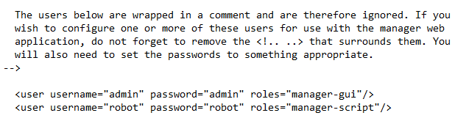

1. You can start the tomcat server using command startup.bat
2. Open browser and type localhost:8080 to open Apache Tomcat/8.5.82 dashboard.

1. Click on manage apps and start the spring application on tomcat server.

1. Click on the application URL / HealthApp (i.e. war file name in webapps), mention application home URL http://localhost:8080/ HealthApp /home

# Finally, the application is deployed on External Tomcat server.

**Prerequisites to be followed to deploy in tomcat.**

* + Make sure you add the tomcat dependency in pom.xml.
  + Then build the .war file and that will be created in target folder and You can name that war file using <finalName> HealthApp </finalName> in pom.xml inside build tag.
  + The URL http://localhost:8080/ HealthApp /home here HealthApp is the name of the war file.